Volatility correlation: NZDUSD and USDCAD
Method 25 / daily |log returns| / rho_vol / Alpari D1 full available history (realized deferred)

Study setup
Logical pair: NZDUSD , USDCAD
Broker symbols: NZDUSD_i , USDCAD_i
Snapshot: 2026-11-03_majors_alpari_D1
Timeframe: D1
Matched return window: 1999-01-05 to 2026-11-02 (UTC bar dates)
Matched return count n: 7190
Dropped unfinished last bar dated 2026-11-03 UTC after a tick-volume check against the prior complete day.
Statistic: rho_vol = Corr(|log return_L|, |log return_R|)
rho_realized: not computed (no intraday buckets in this snapshot)
Complete matched rows (Excel): NZDUSD-USDCAD_Vol_D1.xlsx
Complete matched rows (HTML table): NZDUSD-USDCAD_Vol_D1_data.html

Method carried forward
Volatility correlation rho_vol = Corr(|x_t|, |y_t|) measures whether absolute daily log returns of close move together in size, regardless of sign. Quotes are not inverted. Same-sample signed Pearson r is a side check. The formula sheet also defines within-day realized correlation rho_realized,d from intraday buckets; this v001 uses the Alpari D1 snapshot only, so rho_realized is not computed (no intraday buckets). This is not causation and not a trading signal.

Results (headline)
rho_vol: 0.451792
Pearson r (signed): -0.587831
mean |NZDUSD|: 0.00566986
mean |USDCAD|: 0.00373076
rho_realized: n/a (D1-only snapshot)

Conclusion
Headline rho_vol for NZDUSD and USDCAD: 0.4518. Signed Pearson r = -0.5878. Mean |return|: 0.005670 (NZDUSD), 0.003731 (USDCAD). rho_realized not computed (D1 snapshot has no intraday buckets). This is absolute-move co-movement, not a trading signal.

Charts
Daily closes

Daily log returns

Absolute returns scatter
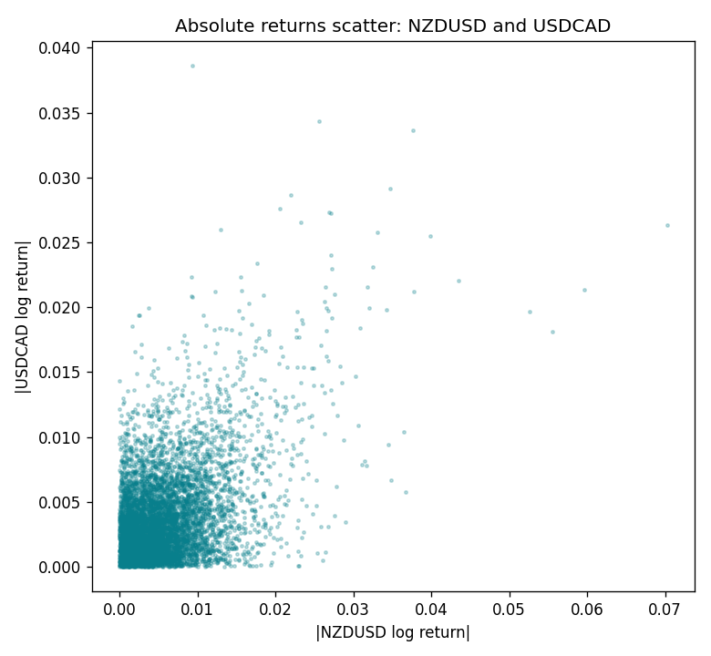

Data report
Matched rows are in the sibling Excel workbook named NZDUSD-USDCAD_Vol_D1.xlsx. Embedding all rows as a Word table is impractical; this file holds column summaries and the first and last 15 matched rows.
Columns: time, NZDUSD_open, USDCAD_open, NZDUSD_high, USDCAD_high, NZDUSD_low, USDCAD_low, NZDUSD_close, USDCAD_close, NZDUSD_tick_volume, USDCAD_tick_volume, NZDUSD_spread, USDCAD_spread, NZDUSD_real_volume, USDCAD_real_volume, NZDUSD_log_return, USDCAD_log_return, NZDUSD_abs_return, USDCAD_abs_return
Column summaries (matched calculation rows)
column | count | mean | std | min | 25% | 50% | 75% | max
NZDUSD_open | 7190 | 0.6563919 | 0.10821436 | 0.3913 | 0.5912925 | 0.6684 | 0.7249075 | 0.88218
USDCAD_open | 7190 | 1.2668559 | 0.16897553 | 0.9168 | 1.118445 | 1.298545 | 1.37213 | 1.6183
NZDUSD_high | 7190 | 0.66030697 | 0.10871111 | 0.3961 | 0.5947025 | 0.67202 | 0.72936 | 0.88421
USDCAD_high | 7190 | 1.2717549 | 0.16892987 | 0.9336 | 1.122975 | 1.30394 | 1.37655 | 1.619
NZDUSD_low | 7190 | 0.65270307 | 0.10781082 | 0.3897 | 0.5880525 | 0.664185 | 0.720965 | 0.87988
USDCAD_low | 7190 | 1.2623003 | 0.16901312 | 0.9056 | 1.114125 | 1.293585 | 1.36785 | 1.6102
NZDUSD_close | 7190 | 0.65646372 | 0.10821182 | 0.3907 | 0.5915625 | 0.66842 | 0.725015 | 0.8822
USDCAD_close | 7190 | 1.266877 | 0.16895077 | 0.916 | 1.118165 | 1.298615 | 1.372425 | 1.6137
NZDUSD_tick_volume | 7190 | 68672.777 | 123109.57 | 16 | 5561.25 | 33864.5 | 58508 | 1127682
USDCAD_tick_volume | 7190 | 80995.8 | 147287.89 | 37 | 5534 | 40938 | 71622.5 | 1410818
NZDUSD_spread | 7190 | 30.299444 | 25.655426 | 0 | 9 | 17 | 50 | 80
USDCAD_spread | 7190 | 23.448679 | 18.267866 | 0 | 9 | 17 | 40 | 60
NZDUSD_real_volume | 7190 | 1.6692087e+10 | 8.4955308e+10 | 0 | 0 | 0 | 0 | 2.705649e+12
USDCAD_real_volume | 7190 | 1.8371592e+10 | 9.6675129e+10 | 0 | 0 | 0 | 0 | 2.5751613e+12
NZDUSD_log_return | 7190 | 6.02e-06 | 0.00764513 | -0.07027433 | -0.00425619 | 0.00022347 | 0.00457637 | 0.05966839
USDCAD_log_return | 7190 | -9.38e-06 | 0.0051433 | -0.03859748 | -0.00283202 | 5.381e-05 | 0.00272817 | 0.03436319
NZDUSD_abs_return | 7190 | 0.00566986 | 0.00512799 | 0 | 0.00203849 | 0.00443797 | 0.00776834 | 0.07027433
USDCAD_abs_return | 7190 | 0.00373076 | 0.00354022 | 0 | 0.00124192 | 0.0027927 | 0.00507788 | 0.03859748
First 15 matched rows (selected columns)
time | NZDUSD_log_return | USDCAD_log_return | NZDUSD_abs_return | USDCAD_abs_return
1999-01-05 | -0.0018597736 | -0.010131666 | 0.0018597736 | 0.010131666
1999-01-06 | 0.0020455609 | -0.0003306769 | 0.0020455609 | 0.0003306769
1999-01-07 | 0.0062963171 | 0.0015202092 | 0.0062963171 | 0.0015202092
1999-01-08 | -0.00055396548 | -0.0020495197 | 0.00055396548 | 0.0020495197
1999-01-11 | 0.010290425 | -0.0035137769 | 0.010290425 | 0.0035137769
1999-01-12 | -0.0053157489 | 0.0066194721 | 0.0053157489 | 0.0066194721
1999-01-13 | -0.0099742238 | 0.0045420214 | 0.0099742238 | 0.0045420214
1999-01-14 | -0.00018564931 | 0.0069376546 | 0.00018564931 | 0.0069376546
1999-01-15 | -0.00074294208 | -0.0056905671 | 0.00074294208 | 0.0056905671
1999-01-18 | -0.0018597736 | 0.00098344542 | 0.0018597736 | 0.00098344542
1999-01-19 | 0.0018597736 | 0.002748513 | 0.0018597736 | 0.002748513
1999-01-20 | 0.0040793678 | -0.0059646885 | 0.0040793678 | 0.0059646885
1999-01-21 | 0.0040627941 | -0.0042823796 | 0.0040627941 | 0.0042823796
1999-01-22 | -0.012051689 | 0.0025057712 | 0.012051689 | 0.0025057712
1999-01-25 | -0.0035504102 | 0.00085579808 | 0.0035504102 | 0.00085579808
Last 15 matched rows (selected columns)
time | NZDUSD_log_return | USDCAD_log_return | NZDUSD_abs_return | USDCAD_abs_return
2026-10-13 | 0.0047326165 | -0.0046395653 | 0.0047326165 | 0.0046395653
2026-10-14 | -0.0037306483 | 0.0015184751 | 0.0037306483 | 0.0015184751
2026-10-15 | 0.0047634855 | -0.0036101503 | 0.0047634855 | 0.0036101503
2026-10-16 | 0.0057501001 | -0.0034322068 | 0.0057501001 | 0.0034322068
2026-10-19 | 0.0018917133 | -0.0018835331 | 0.0018917133 | 0.0018835331
2026-10-20 | 0.0037199341 | -0.0037066008 | 0.0037199341 | 0.0037066008
2026-10-21 | 0.0030923331 | -0.00084691787 | 0.0030923331 | 0.00084691787
2026-10-22 | -0.0033035227 | -0.0026307268 | 0.0033035227 | 0.0026307268
2026-10-23 | 0.0030929853 | 2.85545e-05 | 0.0030929853 | 2.85545e-05
2026-10-26 | -0.0028993932 | 5.7106554e-05 | 0.0028993932 | 5.7106554e-05
2026-10-27 | -0.00026399852 | 0.0025379458 | 0.00026399852 | 0.0025379458
2026-10-28 | -0.0097283914 | -0.0038379274 | 0.0097283914 | 0.0038379274
2026-10-29 | 0.00062190714 | -0.00011436495 | 0.00062190714 | 0.00011436495
2026-10-30 | 0.00019537668 | -0.0010298736 | 0.00019537668 | 0.0010298736
2026-11-02 | -0.0025962955 | 0.00061519094 | 0.0025962955 | 0.00061519094

